A recorded MP4 presentation is not required until your project is scheduled to go to a Committee Meeting. This decision is not made until after the peer review and revision process. Please do not submit a video until asked by staff.
As part of our Committee Meetings, we like to give our applicants the opportunity to present their proposal to our Advisory and Executive Committees through submission of a pre-recorded MP4 presentation.

Our committees appreciate hearing directly from the PI as they convey their enthusiasm, relevant background information, critical research gap, and potential impacts of the work.

While this is not required, if applicants choose to participate, discussion should include:

Relevant background data
Research gap
Hypothesis and aims
Potential clinical impact
Strengths and weaknesses of the proposed approach

The presentation must be under 3 minutes in length.

With PowerPoint:
Open PowerPoint, in the ribbon click on “Slide Show” and “Record Slide Show- Record from Beginning”
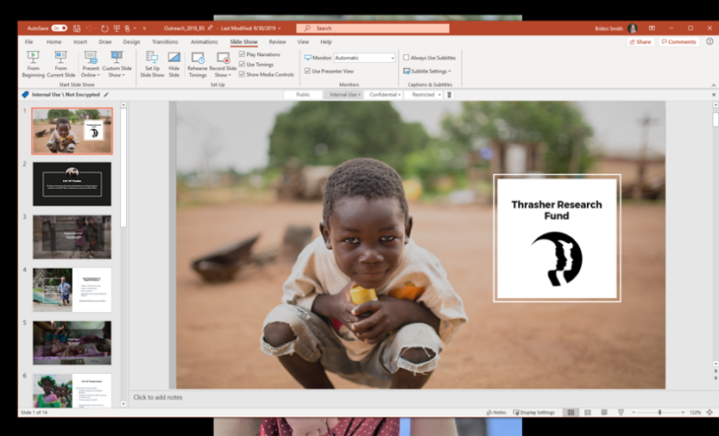

Click “Record”
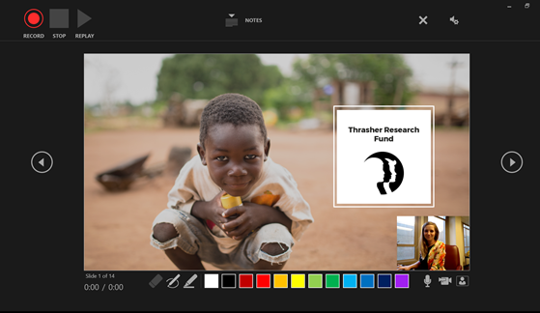
Go through the presentation, using a voiceover or video option. To bring up a pointer, just hold “control” while you click the mouse.

With Keynote:
https://support.apple.com/guide/keynote/record-presentations-tan81813d552/mac
Please export to MP4 so that we can play without issue.

Other recording programs:
Applicants have had success with Zoom, iMovie, and other platforms.
Tips:
Trying to convey your enthusiasm is critical. These can be compelling and help our committee understand the reasons behind the work, what is frustrating about current clinical practice that will be addressed with your proposal?
If you have an international team, it can show strong collaboration if you include project site managers in the presentation.
From a production side, it is ideal to talk louder than you would normally, it helps with playback.

